

Faculty of Informatics and Computer Science

Software Engineering

Word Embedding for Bug Severity Prediction

By: Gloria Ezzat Salib

150753

Supervised By

Dr Abeer Hamdy

June 2019
Abstract
Bug triage system is usually a manual system, where a person, the triager, is in charge of two tasks. One of these tasks is specifying the severity of the bug, depending on its title and description. The bug report can be reported by a user or a developer in the bug repository of the software. As it is a manual process, the severity given to the bug can be inaccurate or inefficient.
This project goal is to improve the bug triage process from manual process to automatic process using machine learning. Determining the severity of the new reported bug took place by analysing the new report’s description and compare it with old solved bugs’ descriptions. The priority label of the new bug is automatically generated and assigned to one of the five severity levels: blocker, trivial, minor, major and critical.
The system has bug reports datasets from open sources bug repositories, Eclipse and Mozilla. The datasets used in this project are pre-processed using natural language processing techniques. Doc2vec, word embeddings technique, is applied on each bug report to represent it as a vector. The bugs’ descriptions, priorities and IDs are the fields used in this system. The new defect report’s description is treated by Doc2vec model then the new vector of the new bug is classified to one of the severity levels using a neural network model or a k nearest neighbour model. Two recurrent neural networks models are created, one is Long Short-Term Memory and Gated Recurrent Units.
Python language is used in implementation, as it contains libraries that deals with natural language processing, word embeddings techniques and neural networks. Pandas library is used to analyse the bug reports, Gensim library is used to apply Doc2Vec technique and Keras library is used to create neural networks models.
Depending on the usage of those techniques, the severity assigned to the new bugs is more accurate than the manual process.

Attestation &Turnitin Report
I understand the nature of plagiarism, and I am aware of the University’s policy on this.
Signature Gloria Ezzat Salib Date 14/6/2019

Acknowledgements
In performing my project, I had to take the help of a respected person, who deserve my gratitude. I am thankful for her aspiring guidance and friendly advice during the project work. I would like to express my special thanks to my supervisor and leader Doctor Abeer Hamdy.
Also, I want to express my appreciation to my parents for providing me with encouragement throughout the process of doing my project.
Table of Contents
Abstract ii
Attestation &Turnitin Report iii
Acknowledgements iv
Table of Contents v
List of Figures vii
List of Tables viii
1 Introduction 1
1.1 Overview 1
1.2 Problem Statement 1
1.3 Scope and Objectives 2
1.4 Report Organization (Structure) 2
1.5 Work Methodology 3
1.6 Work Plan (Gantt Chart) 3
2 Related Work (State-of-The-Art) 4
2.1 Background 4
2.1.1 Bug terminologies 4
2.1.1.1 Bug in Software Environment 4
2.1.1.2 Bug Report 4
2.1.1.3 Bug Severity 4
2.1.1.4 Bug Triage 4
2.1.1.5 Bug Repository or Bug Tracking System 4
2.1.1.6 Automatic Bug Tracking Software 5
2.1.1.7 Bug tracking tools 5
2.1.2 Natural Language Processing 6
2.1.2.1 Pre-processing 6
2.1.3 Word Embedding 6
2.1.3.1 Word Frequency/ Word Weight 6
2.1.3.2 Word2Vec 6
2.1.3.3 Doc2Vec 7
2.1.4 Classification Technique 7
2.1.4.1 K-nearest neighbour (KNN) 7
2.1.4.2 Support Vector Machine (SVM) 8
2.1.4.3 Naïve Bayes 8
2.1.5 Neural Networks (NN) 9
2.1.5.1 Recurrent Neural Network (RNN) 9
2.1.6 Tools and Libraries used 11
2.1.6.1 Pandas 11
2.1.6.2 Gensim 11
2.1.6.3 Keras 11
2.2 Literature Survey and Analysis of the Related Work 12
3 Proposed solution 16
3.1 Solution Methodology 16
3.2 Functional/ Non-functional Requirements 19
3.3 Design / Simulation set up 20
4 Implementation 21
5 Testing and evaluation 22
5.1 Testing 22
5.2 Evaluation 22
6 Results and Discussions 23
7 Conclusions and Future Work 30
7.1 Summary 30
7.2 Future Work 31
References 32
Appendix 1 Neural Networks Types 33
Appendix 2 – User guide 34
Appendix 3 – Installation guide 35

List of Figures
Figure 1 Gantt Chart 3
Figure 2 Bug Report Life Cycle 5
Figure 3 Distance Metrics 7
Figure 4 Euclidean Distance 7
Figure 5 Support Vector Machine 8
Figure 6 Support Vectors 8
Figure 7 Naive Bayes 8
Figure 8 Neural Network Example 9
Figure 9 Neuron 9
Figure 10 Recurrent Neural Network 9
Figure 11 Long Short-Term Memory 10
Figure 12 LSTM diagram 10
Figure 13 Gated Recurrent Unit 10
Figure 14 GRU diagram 10
Figure 15 Datasets Work Methodology 17
Figure 16 New Bug Severity Prediction 18

List of Tables
Table 1 Literature Survey 12
Table 2 KNN built in Results 23
Table 3 KNN from scratch Results 25
Table 4 Accuracy and Error Rates for both KNN built in and from scratch 27
Table 5 SVM and Naive Bayes Results 28
Table 6 GRU and LSTM Results 29

Introduction

Overview
A result of the appearing of bugs in software systems, the number of bug reports increases every day more than the day before. A developer or a user can report a bug found in his system. These bug reports are stored in bug repositories that are checked by triagers. A triager is a person who is responsible of the triaging process. Triaging process is divided into two tasks to do with a bug: decide the level of severity of the new bug and assign it to the developer that has experience with similar bugs. Bug severity classification of software bugs is the indication of the impact that the bug has on the system.
There has been a need of developing an automatic system that transforms the triaging process or to be more accurate, to transform the bug severity prediction process to an automatic process to improve the efficiency of the process.
To automate this process, some machine learning and deep learning techniques are used.
Machine learning techniques are widely used in different types of applications such as classifying text, images and videos, as they are providing intelligent assistants to humans.
One of the applications of machine learning that gained attention recently, is the vectorization of text and its use in text classification and in linguistic analysis.
Word embedding, one of the natural language processing techniques, represents words or documents as vectors to easily classify them and find similarities and relations to each other. This technique contains two models: Word2Vec and Doc2Vec.
Motivated by this hypothesis, I decided to apply ‘Doc2Vec’ model and test its vectors whether they can be classified using basic classification techniques like K nearest neighbour or support vector machine, and neural networks models. As I am doing text classification, I used Recurrent Neural Networks models: Long Short-Term Memory and Gated Recurrent Units.

Problem Statement
A company that has a big software system, needs to follow up the system’s issues by using a bug repository system. A bug repository receives huge quantity of bug reports each day. To determine the severity of each bug, it is a big load on a human that leads to the inaccuracy of the severity assigned to the bug. It also depends on the triager’s experience. This process costs huge amount of money and wastes a lot of time as a one or more persons must indicate the severity of a new issue and elect it to a programmer who has good experience of this bug’s type. Many companies spend around 40% of cost to fix bugs [2].

Scope and Objectives
The main objective of this project is to determine the severity of new bugs automatically using machine learning and deep learning to improve the efficiency and accuracy of the bug severity and reduce the time wasted in the bug triaging process.
This objective is accomplished by applying Doc2Vec model on new bugs and apply a classifier on the resulted vector to specify the severity level. Recurrent neural network, k nearest neighbour and vector space model classifiers are used to predict the class of severity for new bugs. Confusion matrix is used to compute some rates such as F-measure, Precision and True positive rate.

Report Organization (Structure)
This report is about the work through the project, it explains the overview of the project and the techniques that will be used. It will also demonstrate the terminologies that will be used through the whole project. This dissertation is divided into chapters, each chapter explains different thing than the others.
First chapter is the background section that explains all the terminologies related to the project starting from the meaning of a bug until the libraries that will be used. It is also about the related work and literature review that shows the techniques used in other papers and a comparison between them.
Second chapter explains the proposed solution with the detailed methodology and system functionalities and design.
Third chapter is about the implementation of the system and its algorithms. It explains the built-in functions used and its parameters.
Fourth chapter is about the testing and evaluation of the work.
Fifth chapter discusses the results of each classifier.
Sixth, the last chapter, explains the future work and summarize the achievements.

Work Methodology
- Read about bug tracking systems and bug triaging process.
- Analyse information about most popular bug triaging tools.
- Look over related work techniques.
- Study Python language.
- Study Word Embeddings techniques and Gensim library.
- Study classification techniques (K nearest neighbour algorithm, Support Vector Machine algorithm, Naïve Bayes algorithm).
- Study Neural Networks techniques and Keras library.
- Implement Doc2Vec model.
- Implement classification models.
- Apply classification models on Doc2Vec model and test them.

Work Plan (Gantt Chart)

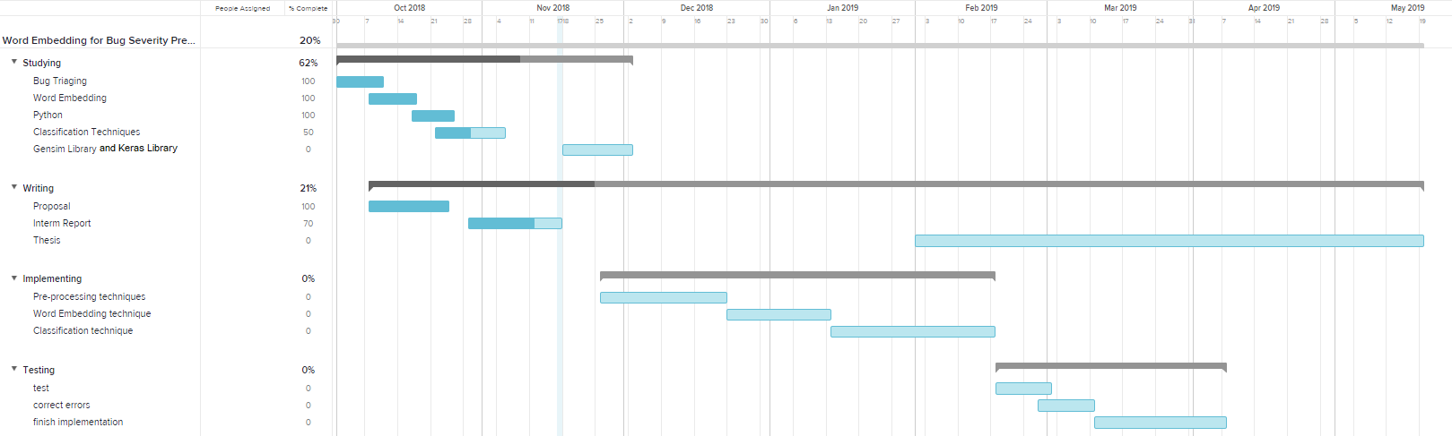
Figure 1 Gantt Chart

Related Work (State-of-The-Art)

Background

Bug terminologies

Bug in Software Environment
A bug is an error or a failure that affects or harms the software in an unexpected way. As for example, when a software is expected to show an image and the image has not been shown, that is a bug in the software.

Bug Report
It a document written by a user or a developer while using the software and finding a bug. This document has a specific formula to be written with. As a bug report should contain a description of the bug, the level of severity, the status of the bug, the date of the day that the bug was found in, the developer that the bug is assigned to and the title of the bug.

Bug Severity
Every bug has a severity level which is the level of harshness of the bug. The desire of the severity in a bug report is to determine how fast should this bug be fixed. There are five severity levels, that one of them is assigned to each bug, which are blocker, critical, major, minor and trivial.

Bug Triage
Bug triaging is a process in which the bug report is screened, and the severity of the bug is determined by a bug triager. After determining the severity of the bug, it is assigned to a specific developer, who has a good experience with similar bugs, to be solved by.

Bug Repository or Bug Tracking System
It is a software application that records all bug reports reported for its companies’ software applications. In bug tracking software, usually a person, known as bug triager, is the one who specify the severity level of the bug and the developer to which the bug should be assigned to. As examples for open source bug tracking software: JIRA, Bugzilla and Mozilla.

Automatic Bug Tracking Software
An automatic software is a software that solves the problem or do specified work by training itself using artificial intelligence and machine learning techniques. In automatic bug tracking system, depending on the bug’s description, the severity and the developer are determined automatically.
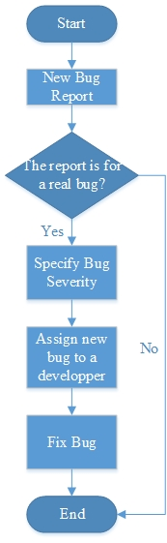
Figure 2 Bug Report Life Cycle

Bug tracking tools
There are many tools for tracking bug that exist in many software companies. There are open source and payed tools that companies buy to track bugs. From the open source tools, the popular ones are Jira and Bugzilla.

Natural Language Processing
It is a field in artificial intelligence which is responsible of the cooperation between the human language and the machine language. It is in charge of the programming process to analyse natural language and get important information from it.

Pre-processing
It is the first step made on data in data mining process to arrange the data for next process. It transforms the data to a suitable format for the next process which can be word embedding or neural network or any other technique.

Normalization
It is one of pre-processing important steps, which organizes the data by scaling it up or down to use for further steps.

Tokenization
It is another step-in pre-processing, which divides the data into tokens, samples of data that has the same task or characteristics.

Stemming
The last step in pre-processing, which decrease the data by cutting down unnecessarily characters, returning a word to its original.

Word Embedding
Word Embeddings is a technique in natural language processing that projects natural language statements as meaning vectors in shared representation space. It describes a word or a document by a vector of real numbers.

Word Frequency/ Word Weight
It is the density of a word in a document. When a word appears more often in the document, its weight increases and its importance as well.

Word2Vec
It is a model that generates word embeddings by representing words as vectors. It contains some algorithms, skip-gram and continuous bag-of-words models.

Doc2Vec
It is another model that generates word embeddings by representing documents as vectors. It is an extension to Word2Vec that is used to learn how to project a document into a d-dimensional space, to create a numeric representation of a document. It contains distributed bag of words and distributed memory as algorithms.

Classification Technique
It is a technique in data mining that identifies data to which class it belongs, depending on some characteristics. It analyses the data and predict the class of new data. It is the process of predicting the label of data.

K-nearest neighbour (KNN)
It is one of the basic classification algorithms which calculates the distances between the new record and the previous records in the dataset and determine the class of the new record depending on the record with which it has the smallest distance or depending on the k value, where K is the number of neighbours/ records with nearest distances. It calculates distance using one the distance metrics: Euclidean distance, Manhattan distance and Minkowski distance.
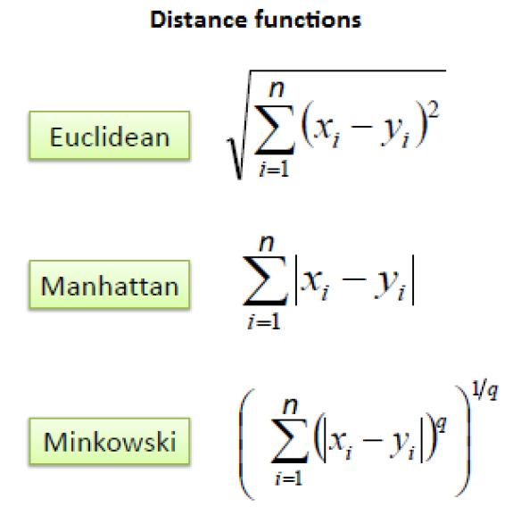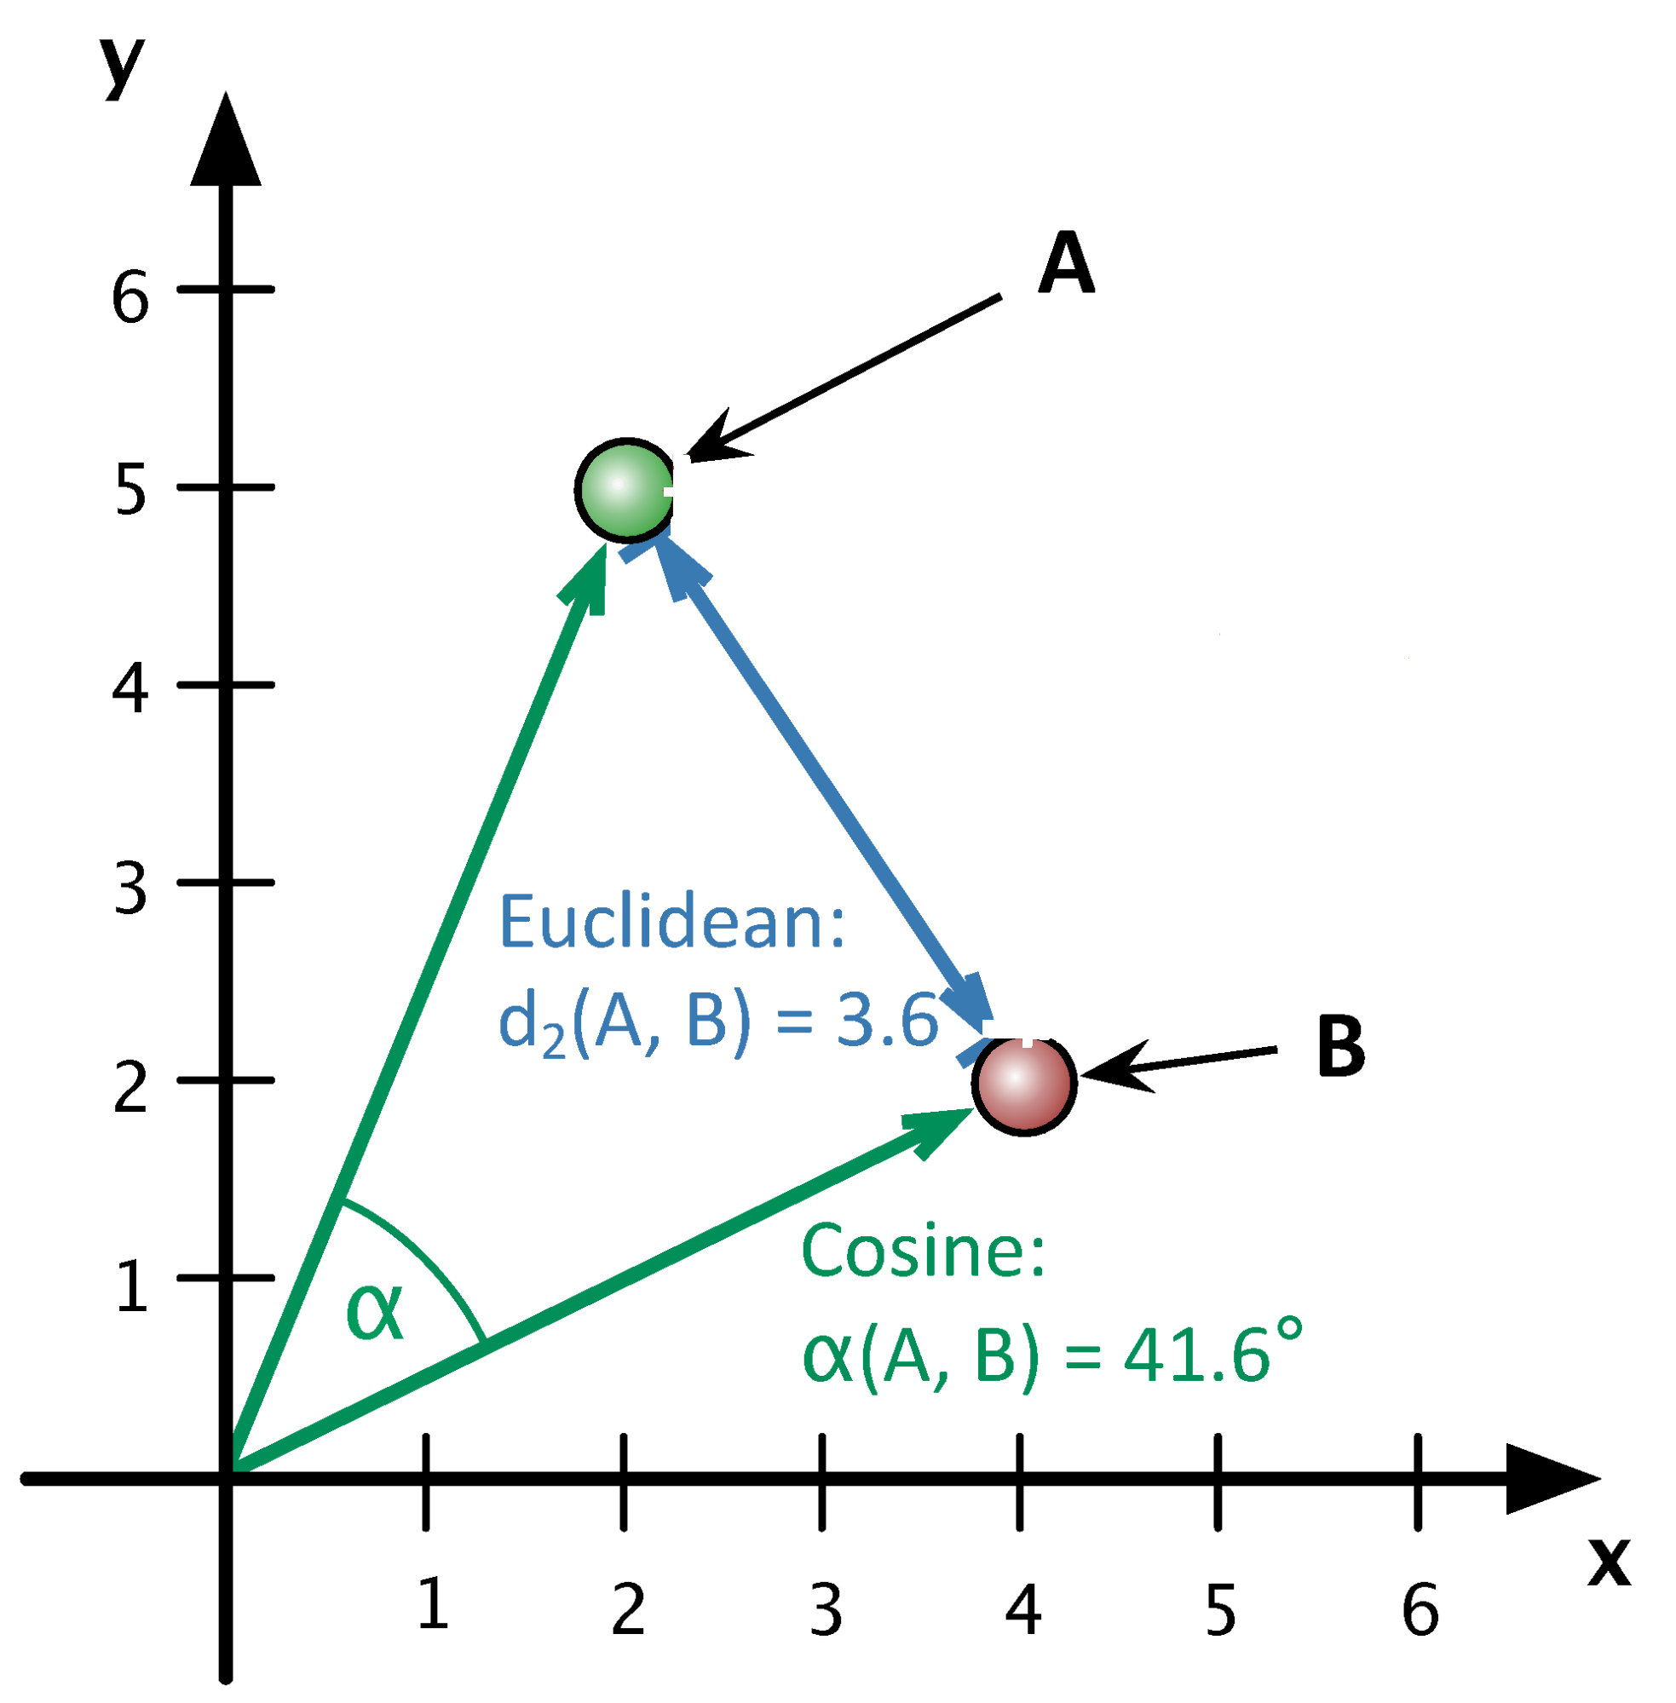
Figure 3 Distance Metrics
Figure 4 Euclidean Distance

Support Vector Machine (SVM)
It is a classification algorithm that is built on separating classes using a line or a hyperplane. In other words, it is an N-dimensional space hyperplane that classifies the data points into N classes of N features. SVM differs from linear classifiers as it has a maximized margin (decision boundary) that is away from any data point. The points that are closest to the boundary are called support vectors which are the separating hyperplane.
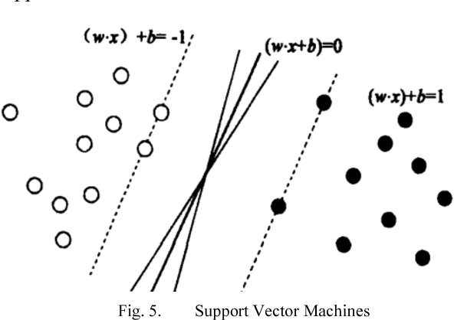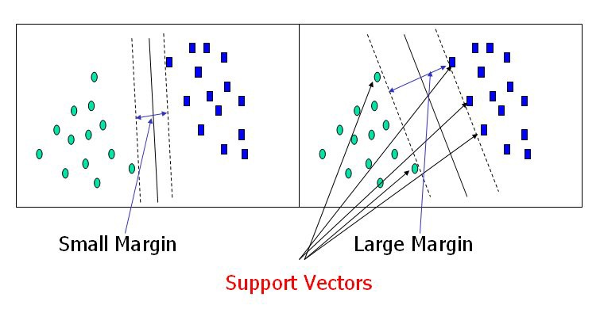
Figure 5 Support Vector Machine
Figure 6 Support Vectors

Naïve Bayes
It is another classification technique that assumes that if a particular feature is in a class is not related to the presence of another feature in the same class. It is a machine learning model used in classifying based on Bayes theorem, which is: 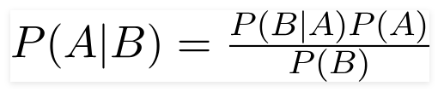
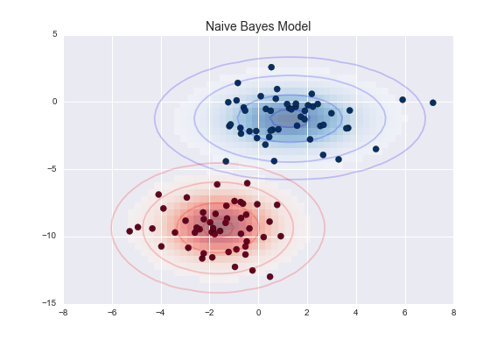
Figure 7 Naive Bayes

Neural Networks (NN)
They are a set of algorithms, modelled as human brain, to recognize patterns. They are part of deep learning, which is part of machine learning which is a branch of computer science that build algorithms that use data to infer models more accurate than human programmers.
Neural networks are algorithms that are built from artificial neurons spread across layers.
A neural network is composed of input layer, hidden layer/s and an output layer.
A neural network layer is composed of number of neurons.
Neuron is a unit that takes inputs, do some operations on them and produces some outputs.
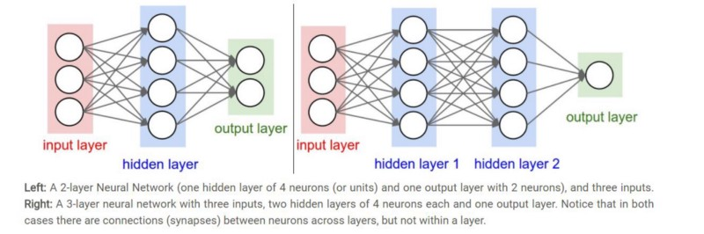
Figure 8 Neural Network Example
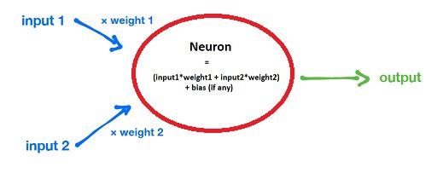
Figure 9 Neuron
Different types of neural networks in appendix 1.

Recurrent Neural Network (RNN)
The recurrent neural network is a neural network type in which the neurons in hidden layers are fed not only using the previous layers output, but also from themselves from the previous pass. In other words, this type’s neurons store information from past.
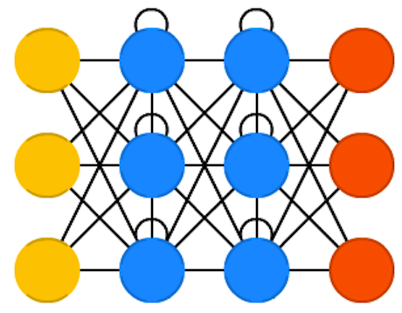
Figure 10 Recurrent Neural Network

Long Short-Term Memory (LSTM)
The LSTM neural network is a type of the RNN with memory cells. Each neuron of the network contains a memory cell and input, output and forget gates. These gates are responsible of allowing the flow of data or stopping it. The input gate determines the information from the previous layer are stored in the neuron. The output layer determines what the next layer gets to know about this neuron. The forget gate forgets unnecessary information for the neuron.
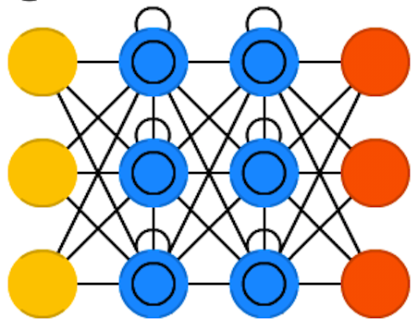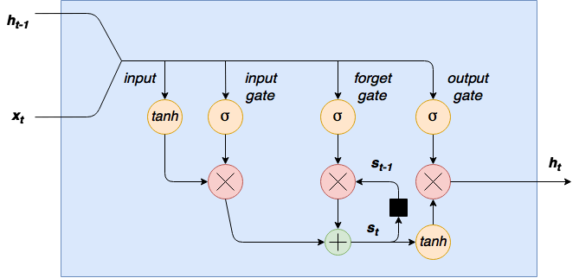
Figure 11 Long Short-Term Memory
Figure 12 LSTM diagram

Gated Recurrent Units (GRU)
The GRU neural network is another type of the RNN which is like LSTM neural network but with a light variation. Instead of having three gates, input, output and forget gates, it has an update gate which is responsible of determining the information it has to keep from the last state and the information that will be in from the previous layer. In other words, it does not have neither a forget gate nor an output gate, instead it has an update gate. It is faster and easier to run than the LSTM but less accurate than the last one.
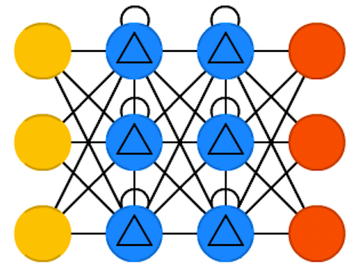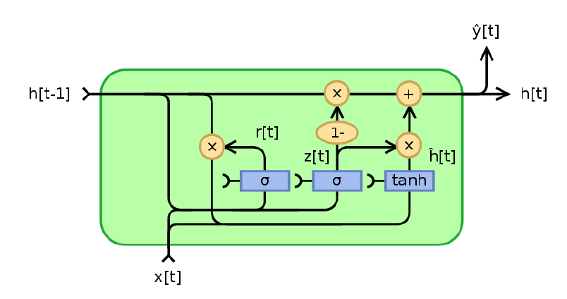
Figure 13 Gated Recurrent Unit
Figure 14 GRU diagram

Tools and Libraries used
In this project, python language will be used as it contains libraries used for the textuality needed for bug reports and used for word embedding techniques.

Pandas
It is a python open source library that is used to analyse data. It takes the data as TSV files or SQL database and save it in Python objects with rows and columns.

Gensim
It is a Python free framework for the implementation of word embeddings technique. It supports word2vec and doc2vec algorithms with their implementations.

Keras
It is a Python open-source library used for crating neural networks. It can run on top of TensorFlow and other python frameworks. It is a user-friendly framework for implementing deep neural networks.

Literature Survey and Analysis of the Related Work
Table 1 Literature Survey
Paper Info | Features | Techniques | Datasets Used
Framework for Automatic Bug Classification in Bug Triage System, by Nikita R. Hiwse, Roshani Talmale [1]. | Determine the class that the new bug belongs. | naïve Bay and k nearest neighbour. | Not mentioned
Implementation on Automated Bugs Triage System with Software Data Reduction Techniques, by Iffat Tanveer Ansari and Mirza Moiz Baig [2]. | Reduce the scale of bug reports datasets and improve the quality of bug data. | Instance selection and feature selection | -Eclipse  -Mozilla
Towards more accurate severity prediction and fixer recommendation of software bugs, by Tao Zhang, Jiachi Chen, Geunseok Yang, Byungjeong Lee and Xiapu Luo [3]. | Predicting bug severity depending on textual similarities and semi-automate the developer assignment. | REP topic algorithm and K-Nearest Neighbour technique. | -GNU Compiler Collection (GCC).  -OpenOffice  -Eclipse -Mozilla  -NetBeans
Dynamic Bug Triage System with Data Classification Techniques, by Swapnil Pasakar, Neha Bagal, Shilpa Nair and Kshitija Godse [4]. | Reduce the noise and redundancy in the bug datasets and improve the bug report data quality. | Support Vector Machine and K-nearest neighbour used with instance and feature selection techniques. | -Eclipse  -Mozilla

Distributed Representation of Sentences and Documents, by Quoc Le and Tomas Mikolov [5]. | Learning fixed-length feature description from variable-length texts. Each document is represented as a vector to be trained to estimate words in the document. | Paragraph Vector. | -Stanford Treebank dataset  -IMDB sentiment analysis dataset.
From Word Embeddings to Document Similarities for Improved Information Retrieval in Software Engineering, by Xin Ye, Hui Shen, Xiao Ma, Razvan Bunescu, and Chang Liu [6]. | Predicting text and code as effective vectors into a shared representation space. | Skip-gram model (word embeddings). | Benchmark datasets.
Combining Word Embedding with Information Retrieval to Recommend Similar Bug Reports, by Xinli Yang, David Lo, Xin Xia, Lingfeng Bao, and Jianling Sun [7]. | Build word embedding vectors based on bug summaries and descriptions and recommend similar bugs. | Word Embeddings. | -Eclipse  -Mozilla
Deep Triage: Exploring the Effectiveness of Deep Learning for Bug Triaging, by Mani, Sankaran and Aralikatte [8]. | Remove noise and unstructured text and deal with the syntactical and sequential word in them. | deep bidirectional recurrent neural  network (DBRNN-A) model. | -Google Chromium  -Mozilla Core  -Mozilla Firefox.
Document Embedding with Paragraph Vectors, by Andrew M. Dai, Christopher Olah and Quoc V. Le [9]. | Measure semantic similarity between long pieces of texts. | Paragraph Vector (Word Embeddings). | -Wikipedia  -arXiv

Many bug severity level techniques have been proposed in the existing papers. These papers use different datasets on which they used their techniques to approve their work. For example:

-Nikita and prof. Roshima, in their paper, chose to use two classification techniques to automate the manual triage system. The two techniques are naïve Bayes (NB) and k nearest neighbour (KNN). These techniques determine to which class the new bug will belongs. They also used instance selection and feature selection techniques for their implementation to reduce the training dataset. Their results were that using naïve Bayes with k nearest neighbour gives better results than using k nearest neighbour only [1].

-Iffat and Mirza, in their paper, discussed the reduction of bug reports datasets by using instance selection and feature selection techniques. They extracted attributes of each bug report and trained it. They tried their proposed automated triage system on two large bug repositories, Eclipse and Mozilla. Their work showed that data reduction can reduce the data scale and improve the accuracy of bug triaging [2].

-Tao and his colleagues, in their paper, proposed the utilisation of the REP topic algorithm, which is the evolution of the REP algorithm, to predict the severity of a new bug. They also proposed to use the KNN classification technique, to semi automate the assignment of the new bug to a developer who has experience with similar bugs. They tried their proposed techniques on five big datasets which are: GNU Compiler Collection (GCC), OpenOffice, Eclipse, NetBeans and Mozilla. Their results proved that the use of REP topic is better than INSpect and NB multinomial and that the use of KNN is better than DRETOM, DREX and DevRec [3].

-Swapnil and his crew selected the SVM and the KNN algorithms to use on their dataset with the help of instance and feature selection techniques to reduce the repetition in the dataset and increase the excellence of bug report used. They also tried to balance between the workload on developers and their history with similar bugs. Their results demonstrate that their proposed methodology can decrease the information scale and increase the perfectness of their automatic bug triage system. Their system can handle bug information in programming maintenance and progress [4].

-Quoc and Tomas, in their paper, discussed the weaknesses of bag-of-words technique and proposed the usage of Paragraph Vector technique that learns fixed-length feature representations from variable-length documents. Paragraph Vector is one of the word embeddings techniques, Doc2Vec technique, which represents each document as a vector which predicts words in the document. They tried their technique on Stanford Treebank dataset and IMDB sentiment analysis dataset. Their results demonstrate that the use of Paragraph Vector technique is better than the bag-of-words technique [5].

-Xin and his team, in their work, used skip-gram technique which is one of word embeddings techniques. They used it to bridge the gap between representations by projecting natural language statements as vectors in a shared space. They tested their work on Benchmark dataset [6].

-Xinli and his team, in their paper, proposed the word embedding technique to be used to represent the bugs. As the technique takes bug titles and description as input and bug severity as output. To prove their work, they used Mozilla and Eclipse as datasets. Their proposed approach improved the performance of bug triaging process as results [7].

-Senthil and his team proved in their paper that the use of deep bidirectional recurrent neural network (DBRNN-A) model provides an accuracy higher than using bag-of-words model, support vector model and naïve Bayes by rank 10. They tried their technique on the title (summary) of the bug and its description. They trained Google Chromium, Mozilla Core and Mozilla Firefox datasets in their research [8].

Andrew, Christopher and Quoc proposed the use of Paragraph Vector technique in their paper. Their technique takes movie review text to predict the sentiment analysis. They estimated the performance of their work by increasing and decreasing the interval of the learned documents. They tested their work using Wikipedia and arXiv datasets. They proved that word embeddings techniques can proceed usefully and give semantic results [9].

Proposed solution

Solution Methodology
In this section, bug severity prediction using word embedding and a classifier is explained. The Doc2Vec technique used is explained, then each classifier used. The classifiers used in this project are K Nearest Neighbour, Support Vector Machine, Naïve Bayes, Gated Recurrent Unit neural network and finally, Long Short-Term Memory neural network.
Before explaining each technique in detail, the steps for performing the classification of bug severity will be demonstrated.
Firstly, the bug reports are stored in CSV files. These bug reports are already cleaned (the datasets used in this project has been cleaned before by one of my colleagues. Pre-processing, normalization, tokenization and stemming techniques were applied on these bug reports). These CSV files are converted into tagged documents using the severity level (label) as the tag of each document (as the Doc2Vec model in Gensim library does not read any type of documents either than tagged documents).
Secondly, the Doc2Vec model is created using Gensim library.
Thirdly, after building the Doc2Vec model, the model trained the dataset and the model is saved to re-use with each classifier.
Fourthly, the classifier is built. In this step the K Nearest Neighbour, Support Vector Machine, Naïve Bayes, Gated Recurrent Unit neural network and Long Short-Term Memory neural network were models were created. The KNN, SVM and Naïve Bayes models were built using Sklearn python library. On the other hand, the GRU and LSTM models were built using Keras library.
Fifthly, after building classifier model, the doc2vec model was divided into training dataset and testing dataset. The trained dataset was trained using each of the classification models. After training the training dataset, the new models were used to predict the severity of the testing dataset.
Finally, in the last step, the performance and accuracy of each model were evaluated using the confusion matrix and classification report which includes the Precision (positive predictive value), the Recall (sensitivity) and F1-score (F-measure).
These steps were used for the available datasets (Eclipse and Mozilla), though they are not used for new bug reports.
The new bug report passes by less steps. The new bug report CSV file is read, then it is converted to a tagged document. The Doc2Vec model is loaded and applied on the new bug tagged document. Finally, the classifier selected by the user is loaded and applied on the vector of the new bug and the severity of it is predicted.
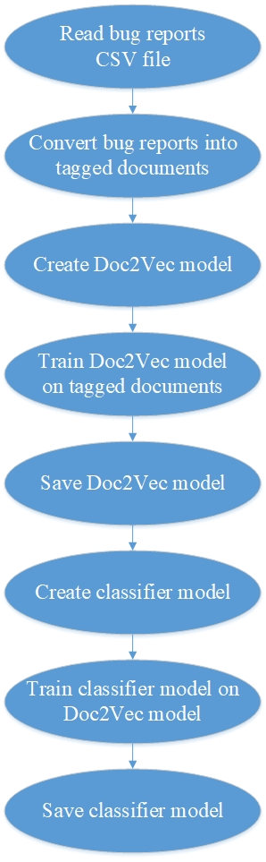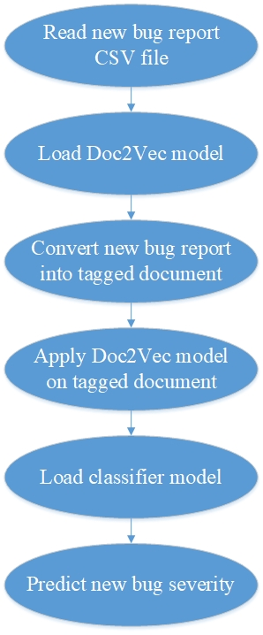
Figure 15 Datasets Work Methodology
Figure 16 New Bug Severity Prediction
The Doc2Vec is an algorithm presented by Gensim, the python library, that is responsible of converting each document to a vector. In the opposite of word2vec model, created also by Gensim, which converts a single word to a vector. In word2vec algorithm, bag of words, the order and semantic of words is neglected in contrast with the doc2vec model which put into consideration the order and semantic of words in each document. For a bug report, the order of words is valuable that is why the use of doc2vec model is better than using word2vec. The input of doc2vec is a sequence of tagged documents. The default algorithm used by gensim is the distributed memory model as its performance is better than the distributed bag of words [10]. This model is built by mapping each document to a unique vector represented as a column in a matrix that holds all the documents and each word is also mapped to a unique vector in another matrix. Both matrices are used to predict the word/label of the context [5].

After creating the doc2vec model for both datasets used in this project, Mozilla and Eclipse, classifier model is created. In this project, it was a comparison between using a simple classifier and neural network which of them is better use with the doc2vec model.

First of the classifiers used was the K nearest neighbor classifier, the very basic classifier. This classifier was used in two different ways, the built-in classifier and the from scratch coded classifier to differentiate which one is better and accurate with vectors. The KNN basic algorithm logic is about calculating the distance between the new record and each member of each class and putting the newest record in the class with which it has the smallest distance with its record/s. The class predicted is the same as only the record with smallest distance or a number K of records. K can be 2 or 5 or 20 or more records. In case that the K is more than 1, the class can be selected by one of this two ways, either by weights or by votes. The weights are given to each class to have different importance. The votes are the number of the nearest records, within the K nearest records, in each class. This algorithm uses in calculating distance Euclidean distance, Manhattan distance or Minkowski distance. This algorithm is also known as non-parametric algorithm, as it does not put a model structure instead its model is demonstrated by its data.

The second classifier used in this project is the support vector machine classifier. The SVM is a machine learning algorithm used in classification. Usually in classification problems, the classes are plotted in n-dimensional space (where n is the number of features/classes). While classifying classes using separating classes by hyperplanes, there is a lot of hyperplanes appear, which is the correct one? The hyperplane with the biggest margin is the best hyperplane. The margin is the distance between the hyperplane and the closest elements of classes from this hyperplane. This is how the SVM algorithm works, it calculates the best hyperplane between classes. The support vectors are the nearest records to the hyperplane. Usually SVM technique is used in linear problems but while using it with non-linear problems, the SVM uses a technique named kernel. The kernels are functions that takes low dimensional input space and convert it to a high dimensional space [12].
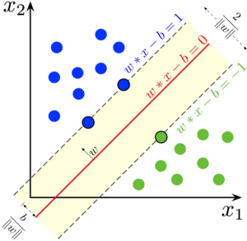
The third classifier used is Naïve Bayes classifier.

Functional/ Non-functional Requirements
Functional:
- Predict new bug severity using KNN.
- Predict new bug severity using SVM.
- Predict new bug severity using Naïve Bayes.
- Predict new bug severity using GRU.
- Predict new bug severity using LSTM.
Non-functional:
- Accuracy: in terms of the severity of the new bug.
- Performance: in terms of the system time behaviour.
- Scalability: in terms of the number of bug reports entered as dataset or for testing.

Implementation 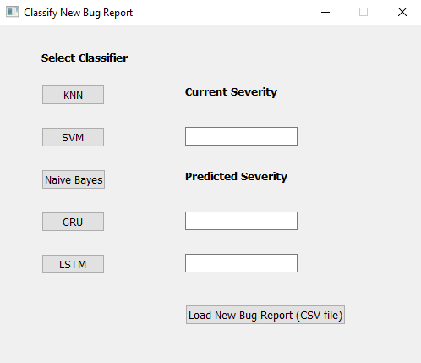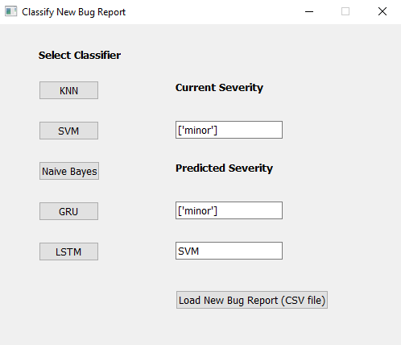

Testing and evaluation

Testing
The testing evaluation for this project was through two ways, the first one is the confusion matrix and the second one is the classification report.
The confusion matrix is a table that present the performance of the classifier model. This matrix presents the combinations of actual classes values and the predicted values using 4 different combinations, true positive (if the predicted value is positive and it is true), true negative (if the predicted value is negative and it is true), false positive (if the predicted value positive and it is not true) and false negative (if the predicted value is negative and it is false).
The confusion matrix results are used in the second way of testing, the classification report, which includes 3 types of equations to evaluate the model’s accuracy and performance. The 3 functions of the classification report are the precision, the recall and the f1-score functions.
The precision function calculates how often does the model predicts correctly in all the classes. In other words, precision is the ratio of correct positive predictions to the actual values of the class.
The recall function calculates how often does the model predicts correctly in all positives classes. In other words, recall is the ratio of correct positive predictions to the all predicted results.
The F1 score (F-measure) is the combination of both functions. It is the harmonic mean of recall and precision functions.
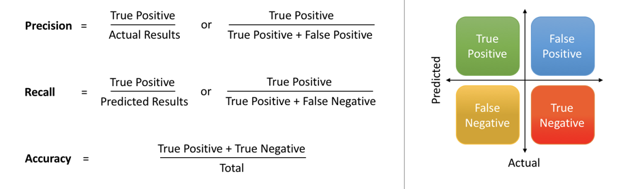
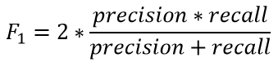
In the next section, tables of comparison of each model confusion matrix and classification report are demonstrated.

Evaluation
 | K=1 | K=5 | K=10 | K=15 | K=20 | K=25
Mozilla  Confu-sion  Matrix | [[46 13 13 8 5]  [ 8 71 38 21 14]  [18 43 78 45 26]  [11 14 47 90 46]  [ 8 10 35 49 32]] | [[ 52 9 9 11 4]  [ 5 85 40 16 6]  [ 16 42 102 43 7]  [ 8 17 57 90 36]  [ 6 15 41 54 18]] | [[ 47 7 17 12 2]  [ 4 78 49 14 7]  [ 11 28 109 47 15]  [ 8 12 64 91 33]  [ 2 6 37 57 32]] | [[ 48 3 22 8 4]  [ 4 68 55 13 12]  [ 9 16 123 44 18]  [ 5 6 71 93 33]  [ 3 3 40 63 25]] | [[ 49 2 20 12 2]  [ 3 65 57 18 9]  [ 8 13 127 44 18]  [ 5 4 75 98 26]  [ 1 0 43 68 22]] | [[ 49 1 20 12 3]  [ 1 64 58 20 9]  [ 9 12 125 49 15]  [ 2 4 78 103 21]  [ 0 0 45 70 19]]
Eclipse  Confu-sion  Matrix | [[ 48 52 81 27 11]  [ 49 137 172 41 33]  [ 78 162 457 130 68]  [ 16 51 96 183 70]  [ 9 38 66 66 72]] | [[ 72 36 92 16 3]  [ 44 144 207 24 13]  [ 80 154 538 98 25]  [ 17 43 148 175 33]  [ 13 41 79 65 53]] | [[ 54 33 116 13 3]  [ 35 123 240 25 9]  [ 70 99 620 93 13]  [ 14 23 170 179 30]  [ 7 34 93 68 49]] | [[ 56 29 118 11 5]  [ 30 112 249 29 12]  [ 55 79 655 95 11]  [ 9 31 175 179 22]  [ 2 31 103 67 48]] | [[ 49 26 129 10 5]  [ 29 101 264 28 10]  [ 49 62 684 87 13]  [ 8 24 179 190 15]  [ 2 26 108 70 45]] | [[ 42 21 141 11 4]  [ 24 89 283 26 10]  [ 42 55 700 86 12]  [ 5 22 197 182 10]  [ 2 26 115 72 36]]

 | SVM | Naïve Bayes | GRU | LSTM
Mozilla | [[ 39 3 28 15 0]  [ 5 62 68 15 2]  [ 2 21 130 51 6]  [ 1 5 65 117 20]  [ 1 3 36 68 26]] | [[39 18 15 7 6]  [14 68 32 10 28]  [ 6 50 82 24 48]  [ 0 41 38 55 74]  [ 2 20 29 25 58]] | [[ 28 16 28 7 6]  [ 3 69 58 18 4]  [ 1 22 121 60 6]  [ 2 13 70 104 19]  [ 0 6 36 73 19]] | [[ 35 9 25 12 4]  [ 4 65 49 27 7]  [ 4 33 94 75 4]  [ 0 18 53 123 14]  [ 0 10 40 74 10]]
Eclipse | [[ 30 15 167 3 4]  [ 12 91 309 18 2]  [ 23 12 800 54 6]  [ 3 6 228 161 18]  [ 2 14 161 54 20]] | [[113 38 36 22 10]  [101 122 80 89 40]  [216 138 205 239 97]  [ 40 24 50 217 85]  [ 27 27 14 100 83]] | [[ 13 30 171 4 1]  [ 4 111 296 16 5]  [ 6 56 777 50 6]  [ 1 11 272 117 15]  [ 0 24 144 59 24]] | [[ 24 25 163 7 0]  [ 8 84 318 15 7]  [ 18 38 771 53 15]  [ 6 6 264 120 20]  [ 0 20 163 51 17]]

 | Mozilla Classification Report | Eclipse Classification Report
K=1 | precision recall f1-score support  blocker 0.51 0.54 0.52 85  critical 0.47 0.47 0.47 152  major 0.37 0.37 0.37 210  minor 0.42 0.43 0.43 208  trivial 0.26 0.24 0.25 134  micro avg 0.40 0.40 0.40 789  macro avg 0.41 0.41 0.41 789  weighted avg 0.40 0.40 0.40 789 | precision recall f1-score support  blocker 0.24 0.22 0.23 219  critical 0.31 0.32 0.31 432  major 0.52 0.51 0.52 895  minor 0.41 0.44 0.42 416  trivial 0.28 0.29 0.29 251  micro avg 0.41 0.41 0.41 2213  macro avg 0.35 0.35 0.35 2213  weighted avg 0.41 0.41 0.41 2213
K=5 | precision recall f1-score support  blocker 0.60 0.61 0.60 85  critical 0.51 0.56 0.53 152  major 0.41 0.49 0.44 210  minor 0.42 0.43 0.43 208  trivial 0.25 0.13 0.18 134  micro avg 0.44 0.44 0.44 789  macro avg 0.44 0.44 0.44 789  weighted avg 0.42 0.44 0.43 789 | precision recall f1-score support  blocker 0.32 0.33 0.32 219  critical 0.34 0.33 0.34 432  major 0.51 0.60 0.55 895  minor 0.46 0.42 0.44 416  trivial 0.42 0.21 0.28 251  micro avg 0.44 0.44 0.44 2213  macro avg 0.41 0.38 0.39 2213  weighted avg 0.44 0.44 0.43 2213
K=10 | precision recall f1-score support  blocker 0.65 0.55 0.60 85  critical 0.60 0.51 0.55 152  major 0.39 0.52 0.45 210  minor 0.41 0.44 0.42 208  trivial 0.36 0.24 0.29 134  micro avg 0.45 0.45 0.45 789  macro avg 0.48 0.45 0.46 789  weighted avg 0.46 0.45 0.45 789 | precision recall f1-score support  blocker 0.30 0.25 0.27 219  critical 0.39 0.28 0.33 432  major 0.50 0.69 0.58 895  minor 0.47 0.43 0.45 416  trivial 0.47 0.20 0.28 251  micro avg 0.46 0.46 0.46 2213  macro avg 0.43 0.37 0.38 2213  weighted avg 0.45 0.46 0.44 2213
K=15 | precision recall f1-score support  blocker 0.70 0.56 0.62 85  critical 0.71 0.45 0.55 152  major 0.40 0.59 0.47 210  minor 0.42 0.45 0.43 208  trivial 0.27 0.19 0.22 134  micro avg 0.45 0.45 0.45 789  macro avg 0.50 0.45 0.46 789  weighted avg 0.47 0.45 0.45 789 | precision recall f1-score support  blocker 0.37 0.26 0.30 219  critical 0.40 0.26 0.31 432  major 0.50 0.73 0.60 895  minor 0.47 0.43 0.45 416  trivial 0.49 0.19 0.28 251  micro avg 0.47 0.47 0.47 2213  macro avg 0.45 0.37 0.39 2213  weighted avg 0.46 0.47 0.45 2213
K=20 | precision recall f1-score support  blocker 0.74 0.58 0.65 85  critical 0.77 0.43 0.55 152  major 0.39 0.60 0.48 210  minor 0.41 0.47 0.44 208  trivial 0.29 0.16 0.21 134  micro avg 0.46 0.46 0.46 789  macro avg 0.52 0.45 0.46 789  weighted avg 0.49 0.46 0.45 789 | precision recall f1-score support  blocker 0.36 0.22 0.28 219  critical 0.42 0.23 0.30 432  major 0.50 0.76 0.61 895  minor 0.49 0.46 0.47 416  trivial 0.51 0.18 0.27 251  micro avg 0.48 0.48 0.48 2213  macro avg 0.46 0.37 0.38 2213  weighted avg 0.47 0.48 0.45 2213
K=25 | precision recall f1-score support  blocker 0.80 0.58 0.67 85  critical 0.79 0.42 0.55 152  major 0.38 0.60 0.47 210  minor 0.41 0.50 0.45 208  trivial 0.28 0.14 0.19 134  micro avg 0.46 0.46 0.46 789  macro avg 0.53 0.45 0.46 789  weighted avg 0.50 0.46 0.45 789 | precision recall f1-score support  blocker 0.37 0.19 0.25 219  critical 0.42 0.21 0.28 432  major 0.49 0.78 0.60 895  minor 0.48 0.44 0.46 416  trivial 0.50 0.14 0.22 251  micro avg 0.47 0.47 0.47 2213  macro avg 0.45 0.35 0.36 2213  weighted avg 0.46 0.47 0.43 2213

 | Mozilla Classification Report | Eclipse Classification Report
SVM | precision recall f1-score support  blocker 0.81 0.46 0.59 85  critical 0.66 0.41 0.50 152  major 0.40 0.62 0.48 210  minor 0.44 0.56 0.49 208  trivial 0.48 0.19 0.28 134  micro avg 0.47 0.47 0.47 789  macro avg 0.56 0.45 0.47 789  weighted avg 0.52 0.47 0.47 789 | precision recall f1-score support  blocker 0.43 0.14 0.21 219  critical 0.66 0.21 0.32 432  major 0.48 0.89 0.62 895  minor 0.56 0.39 0.46 416  trivial 0.40 0.08 0.13 251  micro avg 0.50 0.50 0.50 2213  macro avg 0.50 0.34 0.35 2213  weighted avg 0.52 0.50 0.44 2213
Naïve Bayes | precision recall f1-score support  blocker 0.64 0.46 0.53 85  critical 0.35 0.45 0.39 152  major 0.42 0.39 0.40 210  minor 0.45 0.26 0.33 208  trivial 0.27 0.43 0.33 134  micro avg 0.38 0.38 0.38 789  macro avg 0.43 0.40 0.40 789  weighted avg 0.41 0.38 0.38 789 | precision recall f1-score support  blocker 0.23 0.52 0.32 219  critical 0.35 0.28 0.31 432  major 0.53 0.23 0.32 895  minor 0.33 0.52 0.40 416  trivial 0.26 0.33 0.29 251  micro avg 0.33 0.33 0.33 2213  macro avg 0.34 0.38 0.33 2213  weighted avg 0.40 0.33 0.33 2213
GRU | precision recall f1-score support  blocker 00.82 0.33 0.47 85  critical 0.55 0.45 0.50 152  major 0.39 0.58 0.46 210  minor 0.40 0.50 0.44 208  trivial 0.35 0.14 0.20 134  micro avg 0.43 0.43 0.43 789  macro avg 0.50 0.40 0.41 789  weighted avg 0.46 0.43 0.42 789 | precision recall f1-score support  blocker 0.54 0.06 0.11 219  critical 0.48 0.26 0.33 432  major 0.47 0.87 0.61 895  minor 0.48 0.28 0.35 416  trivial 0.47 0.10 0.16 251  micro avg 0.47 0.47 0.47 2213  macro avg 0.49 0.31 0.31 2213  weighted avg 0.48 0.47 0.41 2213
LSTM | precision recall f1-score support  blocker 0.81 0.41 0.55 85  critical 0.48 0.43 0.45 152  major 0.36 0.45 0.40 210  minor 0.40 0.59 0.47 208  trivial 0.26 0.07 0.12 134  micro avg 0.41 0.41 0.41 789  macro avg 0.46 0.39 0.40 789  weighted avg 0.42 0.41 0.40 789 | precision recall f1-score support  blocker 0.43 0.11 0.17 219  critical 0.49 0.19 0.28 432  major 0.46 0.86 0.60 895  minor 0.49 0.29 0.36 416  trivial 0.29 0.07 0.11 251  micro avg 0.46 0.46 0.46 2213  macro avg 0.43 0.30 0.30 2213  weighted avg 0.45 0.46 0.39 2213

Results and Discussions
As unexpected results, the SVM model was the more accurate model with the two datasets, Eclipse and Mozilla, as its accuracy was about 50% on Eclipse dataset and 47% on Mozilla dataset. On the other hand, the GRU model’s accuracy was 47% on Eclipse dataset and 43% on Mozilla dataset, the LSTM model’s accuracy was 46% on Eclipse dataset and 41% on Mozilla dataset. While the Naïve Bayes model’s accuracy was 33% on Eclipse dataset and 38% on Mozilla dataset. Finally, the built in KNN model’s accuracy varies from 40% to 48% depending on K value, where k was equal to 1, 5, 10, 15, 20, 25, the highest accuracy was at k=20 which is 48% on Eclipse dataset and 46% on Mozilla dataset. The KNN, coded from scratch, was not good as the built-in KNN as its accuracy was around 40% with all K values and with both datasets.

Conclusions and Future Work

Summary
Bug triage framework is normally a manual framework, where a man, the triager, is accountable for two jobs. One of these jobs is indicating the seriousness of a bug, dependent upon the title and description of the bug report which is explained by a client or a designer in the bug repository of the product. As it is a manual procedure, the suggested severity of the bug could be wrong and wasteful.
This task objective is to enhance the bug triage process from manual procedure to programmed process by deciding the seriousness of the new bug by inspecting the new report's depiction and contrast it with old trained bugs' descriptions.
The open sources bug repositories datasets, Eclipse and Mozilla, are used as datasets for this project. The explained bug reports were pre-handled utilizing pre-processing techniques and afterward each bug will be converted to a vector using word embeddings techniques. The bugs’ reports all fields are used as features for the model which include descriptions, the bud ID, the product and the summary. Any new bug report’s severity is predicted by one of the classifiers’ models, KNN, SVM, Naïve Bayes, GRU and LSTM. At that point the new vector of the new bug is contrasted with the dataset’s information. Python language is used implementation language as it has open source libraries that deals with natural language processing and word embeddings techniques and helps in building different classification models. Pandas library was used to analyse the bug reports csv files, Gensim library was used to create and apply the doc2vec model on both datasets. Sklearn library was used to create KNN, SVM and Naïve Bayes classifiers, to train them on doc2vec models and to predict new bugs’ severity. Keras library was used to create neural networks model, GRU and LSTM (the two RNN models used within the project).
As unexpected results, the SVM model was the more accurate model with these datasets, as its accuracy was about 50% on Eclipse dataset. On the other hand, the GRU model’s accuracy was 47%, the LSTM model’s accuracy was 46%, the Naïve Bayes model’s accuracy was 33% and lastly the KNN accuracy varies from 40% to 48% depending on K value. With Mozilla Dataset, the SVM accuracy was 47%, GRU’s was 43%, LSTM’s was 41%, Naïve Bayes’ was 38% and finally, the KNN’’s was from 40% to 45%.

Future Work
The future work will be about how to improve the models, specially the neural networks’ models. Gathering new bug reports datasets from Jira and other open-source bug repositories, apply from scratch the pre-processing techniques, and not used already pre-processed datasets. Create new Doc2Vec models and apply the classifiers on them to improve the accuracy of the bug severity prediction. Try to create and apply new classifiers like Bidirectional recurrent neural network and others.
References
[1] | P. R. T. Nikita R. Hiwse, “Framework for Automatic Bug Classification in Bug Triage System,” International Conference on Modern Trends in Engineering Science and Technology, vol. 2, no. 6, pp. 65-69, 2016.
[2] | M. M. B. Iffat Tanveer Ansari, “Implementation on Automated Bugs Triage System with Software Data Reduction Techniques,” International Journal of Science and Research, vol. 6, no. 9, 2017.
[3] | J. C. G. y. B. L. X. L. Tao Zhang, “Towards more accurate severity prediction and fixer recommendation of software bugs,” The journal of systems and software, pp. 166 - 184, 2016.
[4] | N. B. S. N. K. G. Swapnil Pasakar, “Dynamic Bug Triage System with Data Classification Techniques,” International Journal of engineering Research & Technology, vol. 4, no. 11, 2015.
[5] | T. M. Quoc Le, “Distributed Representations of Sentences and DOcuments,” International Conference on Machine Learning, 2014.
[6] | H. S. X. M. R. B. C. L. Xin Ye, “From Wor Embeddings to Document Similarities for Improved Retrieval in Software Engineering,” 2016.
[7] | D. L. X. X. L. B. J. S. Xinli Yang, “Combining Word Embedding with Information Retrieval to Recommend Similar Bug Reports,” International Symposium on Software Reliability Engineering, 2016.
[8] | A. S. R. A. Senthil Mani, “DeepTriage: Exploring the Effectiveness of Deep Learning for Bug Triage,” 2018. [Online]. Available: http://bugtriage.mybluemix.net/.
[9] | C. O. Q. V. L. Andrew M. Dai, “Document Embedding with Paragraph Vectors,” arXiv, 2015.
[10] | R. ŘEHŮŘEK, “Doc2vec tutorial,” 15 December 2014. [Online]. Available: https://rare-technologies.com/doc2vec-tutorial/.
[11] | W. L. W. C. W. L. C. Z. Q. W. H. L. Xuesong Yan, “Weighted K-Nearest Neighbor Classification Algorithm Based on Genetic Algorithm,” researchgate, 2013.
[12] | S. RAY, “Understanding Support Vector Machine algorithm from examples (along with code),” 13 September 2017. [Online]. Available: https://www.analyticsvidhya.com/blog/2017/09/understaing-support-vector-machine-example-code/.

Appendix 1 Neural Networks Types
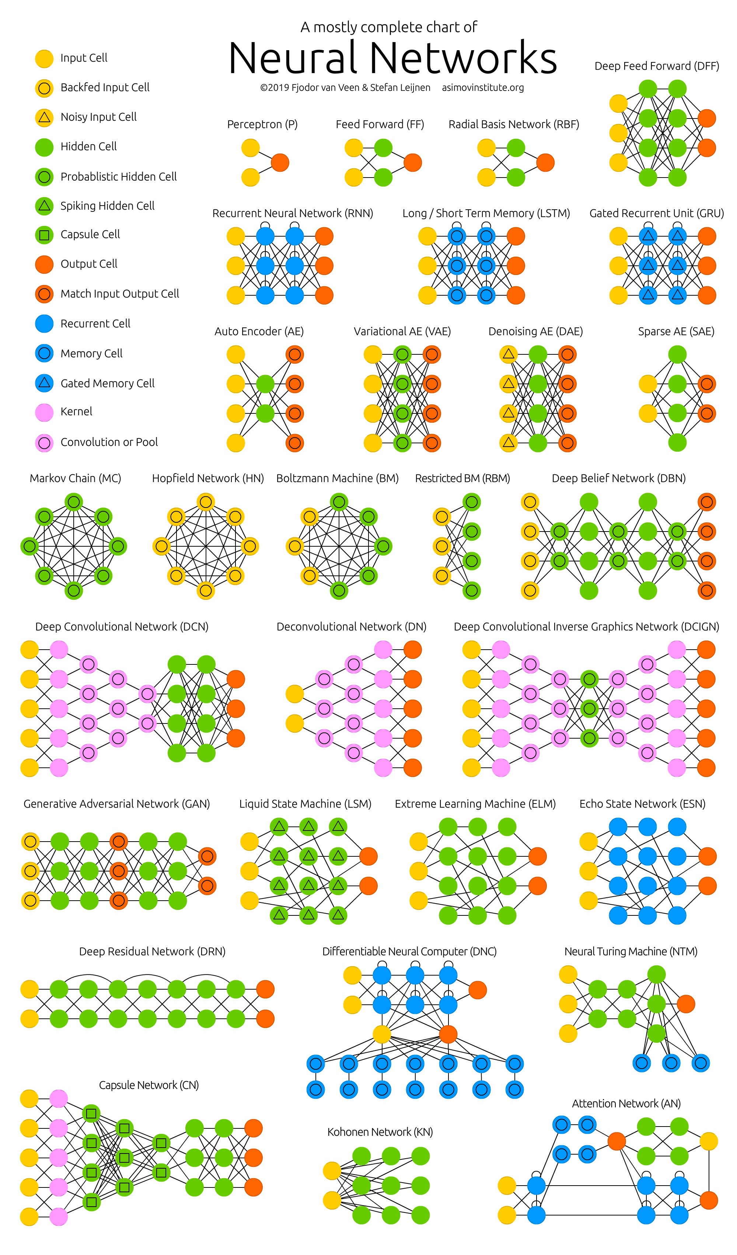
Appendix 2 – User guide
For creating new Doc2Vec model, user should run Doc2Vec.py. For different datasets, csv files should be added in DataSets folder in project directory and changing the input of the read function of the pandas library. The Doc2Vec new model should be saved in Doc2VecModels.
For creating GRU model, user should run GRU.py. For different doc2vec model, the doc2vec model should be loaded using gensim library from Doc2VecModels directory, same for other classifiers.
For creating LSTM model, user should run LSTM.py.
For creating KNN model, user should run KNN.py.
For creating SVM model, user should run SVM.py.
For creating Naïve Bayes model, user should run NaiveBayes.py.
For trying to enter a new bug report and test all the classifiers, the user should run the NewBugClassification.py (the GUI).
Appendix 3 – Installation guide
Python 3.6 should be installed. TensorFlow 1.13 version is really needed to use Keras library. Any version of Keras, Gensim, PyQt5, Sklearn, NumPy, Pickle and pandas can be used.

